PAGE 1

Corby innovation Hub —
June Newsletter 2018

CIH News
Wednesday 27/06/18

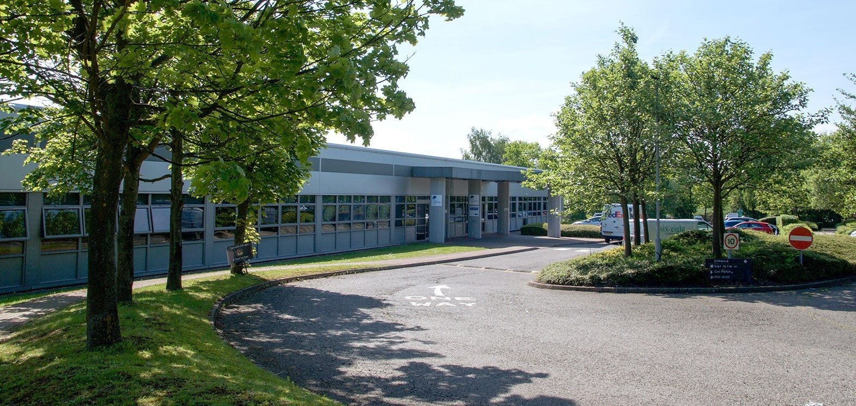Inside this Issue:

Page 1
- CIH Website
- Internal Works
- Catering
- Leavers
- Joiners
Page 2
- DDW Menu
The Corby Innovation Hub Website is now live at http:// corbyinnovationhub.com/

Update on Internal Works at CIH
We are happy to inform you that the Cafe is complete and opened on Monday 25th June.
Catering
Corby Innovation Hub would like to welcome DDW Catering to site on 9th July. (Tbc) Menu on page 2
Leavers
Bespoke Health & Safety — Office 7
TQ Education & Training — Office 12 Joiners
We would like to welcome X P Recruitment to office 5 at Corby Innovation Hub.
PLEASE BE AWARE—Smoking inside the building is not permitted at any time. Please can you ensure all staff are aware of this and to use this designated area in the car park. The Council’s Smoke free policy clearly sets out that smoking, including the use of vaporizers, is prohibited in ALL council premises. Any breach of this policy is considered very serious.

DDW Catering Menu PAGE 2

Hot and cold drinks
Tea: 80p Hot chocolate: £1 Coffee: Gold Blend instant, £1
Others including cappuccino, latte, intenso:£1.50 Bottle drink: £1.25 or as marked.
Bottle water: 80p Orange juice: 80p
Snacks
Bag of crisps: 80p Bar of chocolate: 80p Muffin: £1.30 Giant cookie: 90p
Flapjacks: £1. Millionaire shortbread: £1.20. Packet of biscuits: 60p.
Sandwiches
Cheese & onion £1.80 Cheese & pickle £1.80 Tuna & mayo’ £2.30 Ham & Salad £2.30
Ham & cheese £2.50 Barbecue chicken: £2.50
Fillings in a larger baguette: 20p extra

Hot snacks:
Slice of toast with jam and butter £1 Bacon roll £2.50

Square sausage in a roll £2.50 Freshly made soup with roll £2
Baked potato with one filling: £3
Fillings to include cheese, tuna mayo’, baked beans 50p per extra/topping Freshly-made panini or toastie:
Cheese £2.50
Cheese & tomato £2.60 Cheese & ham £3.10 Cheese & onion £2.60 Tuna & red onion: £3 Tuna & cheese £3.10 Barbecue chicken £3.10
We cannot guarantee any of our food is nut free. We are happy to take orders and to try to meet any special requests for dietary requirements.

